**DAV HZL SR. SEC. SCHOOL, DARIBA**

**TENTATIVE CO-CURRICULAR ACTIVITIES 2024-25**

|  |  |  |
| --- | --- | --- |
| **Date** | **Class** | **Activity (Events)** |
| 06/04/2024 | III TO V | Cinematic Odyssey: Arya Samaj Chronicles |
| VI TO VIII | Narrative Alchemy: Crafting English Tales |
| IX TO XII | Lens Enchantment: Interclass Cinematic Journey |
| 20/04/2024 | III TO V | Soliloquy Symphony: Mastering English Monologues |
| VI TO VIII | Dramatic Flourish: Theatrical Skits in English |
| IX TO XII | Electoral Insights: Interclass PowerPoint Showdown |
| 04/05/2024 | III TO V | Artistry Unleashed: Collage Creation Extravaganza |
| VI TO VIII | Sculpting Stories: From Clay to Chronicle |
| IX TO XI | Pixel Perfection: Design Delights with Photoshop |
| 05/07/2024 | III TO VIII | Green Horizon: Plantation Expedition |
| 06/07/2024 | III TO V | Calligraphy |
| VI TO X | Echoes of Ecology: English Environmental Orations |
| 11/07/2024 | III TO XII | Leadership Unveiled: Investiture Spectacular |
| 20/07/2024 | III TO V | Lexical Showdown: Spellbinding Spell Bee |
| VI TO VII | Verbal Voyage: Vocabulary Ventures |
| IX TO XI | Enlightening Discourse: TED Talk Showdown |
| 03/08/2024 | III TO V | Culinary Chronicles: Fireside Cooking & Artistry |
| VI TO IX | Taste Temptations: Culinary Competition |
| 17/08/2024 | III TO VIII | Cultural Kaleidoscope: Rangoli, Rakhi& Arya Samaj Quizzes |
| 31/08/2024 | III TO V | Social Science Showdown: Quiz Quest |
| VII TO X | Parliamentary Prowess: Youth Debate Showdown |
| 06/09/2024 | III TO V | Hindi Heritage: Crafting Original Stories & Poems |
| VI TO VII | Hindi Heritage: Crafting Original Poems |
| VIII TO X | Declamatory Divinity: Hindi Oratory Odyssey |
| 05/10/2024 | III TO V | Blogosphere Brilliance: Crafting Digital Chronicles |
| VI TO VII | Wall Wonders: Mural Masterpieces |
| VIII | Wonders on earthen plates |
| 19/10/2024 | III TO V | Moral Mosaic: Hindi Skits on Values |
| VI TO IX | Theatrical Tribute: Great Personality Dramatizations |
| 08/11/2024 | III TO V | Melodic Medley: Songster Showdown |
| VI TO IX | Devotional Delights: Bhajan Bliss |
| 23/11/2024` | III TO V | Innovation Illuminated: Inventors' Showcase |
| VI TO VII | Journey of a Dreamer;Biography |
| VIII TO IX Sci. | Scientific Sorcery: Enchanting Science Magic |
| 07/12/2024 | III TO V | Literary Legacy: Bookmark Bonanza |
| VI TO VIII | Informative Imprints: Brochure Brilliance |
| 21/12/2024 | III TO IX | Math Marvels: Exploring Fun & Practical Mathematics |
| 18/01/2025 | III TO VII | Patriotic Penmanship: Slogan Sketching & Doodling |
| 31/01/2025 | III TO V | Resourceful Innovation: Waste Material Wonders & Presentations |

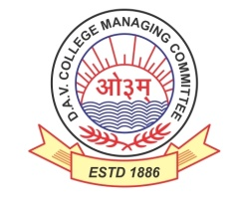

DAV HZL Sr. Sec. School dariba

rajsamand (raj.)

DAV HZL Sr. Sec. School dariba, rajsamand(raj.)

Split-up Syllabus

Class- III

Split-up Syllabus & Activities

for the session

2024-25

Class-VI

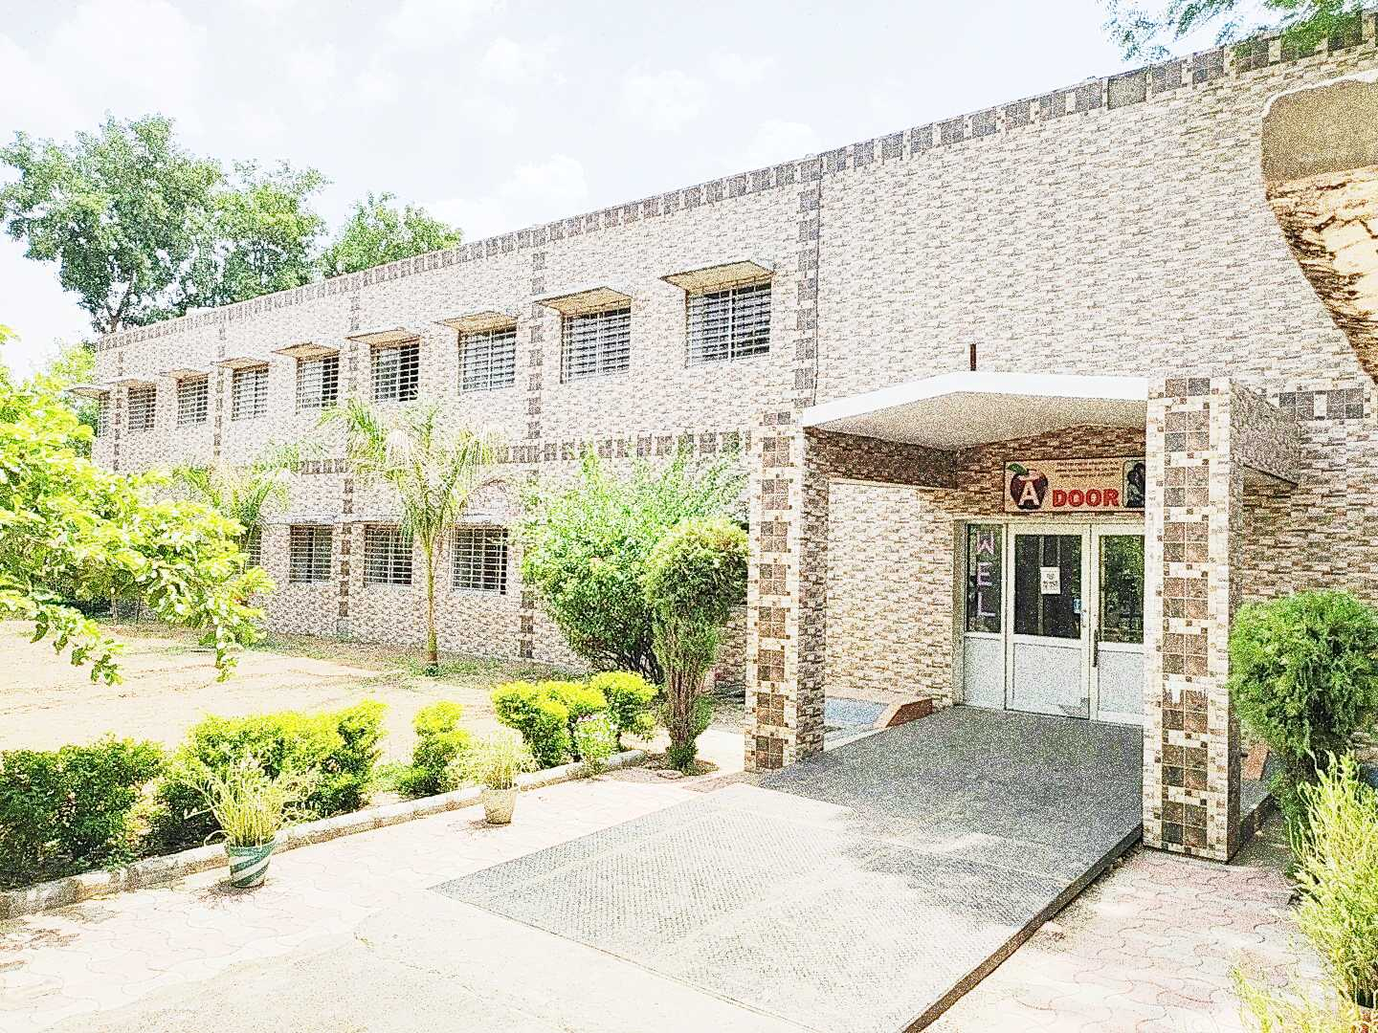

Address : Rajpura-Dariba, Distt. – Rajsamand (Raj.) 313211

Contact : (02952)265130 Email : davhzl_dariba@yahoo.com Website : www.davhzldariba.in

|  |  |  |
| --- | --- | --- |
| **Subject** | **PT- I** | **PT- II** |
| English | English L.-ch 1,2  Practice book –ch 1 | English L–ch 3,4  Practice book–ch 2 |
| Hindi | ज्ञान सागर.-पाठ 1,2  अभ्यास सागर -पाठ 1,2 | ज्ञान सागर - पाठ 3,4  अभ्यास सागर -पाठ 3,4 |
| Maths | L-1,2 | L-3,4 |
| Science | Ch- 1,2 | Ch-3,4 |
| S.St. | Ch– 1, 8 | Ch- 9, 10, 21 |
| laLÑr | पाठ 1,2 व्याकरण-वर्ण संयोजन व विच्छेद | पाठ 3, 4 व्याकरण- सर्वनाम शब्दरूप अव्यय- उपसर्ग |
| Computer Sc. | Ch-1 | Ch-2 |
| Moral Edu. | पाठ 1,2 | पाठ- 3,4 |
| G. K. | Unit- 1 | Unit- 2 |

|  |  |
| --- | --- |
| **Subject** | **Mid Term** |
| English | English L- Ch-1 to 5 English Practice –Ch1 to 5  English Reader- Ch- 1 to 3 |
| Hindi | ज्ञान सागर- पाठ 1 से 10 अभ्यास सागर पाठ 1 से 10 , vifBr x|ka”k o vifBr i|ka”k ,oe O;kdj.k |
| Maths | L- 1 to 5, 8, 9, 10 |
| Science | Ch- 1 to 7 |
| S. St. | Ch- 1, 2, 3, 4, 8, 9, 10, 11, 12, 13, 14, 15, 21 |
| laLÑr | पाठ 1 से 6 व्याकरण-वर्ण संयोजन व विच्छेद , सर्वनाम शब्दरूप  धातुरूप संधि , अव्यय- उपसर्ग, प्रत्यय , संख्या , कारका: , vifBr x|ka”k पत्र लेखन , चित्र वर्णन संवाद लेखन , कथा लेखन |
| Computer Sc. | Ch- 1 to 4 |
| Moral Edu. | पाठ 1 से 7 ( आर्य समाज के नियम 1-5 ) |
| G. K. | Unit – 1,2,3 |
| Drawing | Page No. 2 to 20 |

|  |  |
| --- | --- |
| **Subject** | **PT- III** |
| English | English Lit –Ch– 6,7  Practice book –Ch- 6 |
| Hindi | ज्ञान सागर व अभ्यास सागर में पाठ 12, 13 |
| Maths | L-6,7 |
| Science | Ch- 8, 9 |
| S.St. | Ch- 16, 17, 22 |
| laLÑr | पाठ 7 व 8  संवाद, पत्रलेखन |
| Computer Sc. | Ch-5, 6 |
| Moral Edu. | पाठ 8,9 |
| G. K. | Unit- 4 |

|  |  |
| --- | --- |
| **Subject** | **Final Term** |
| English | English Lit.- Ch.-6 to 11 Practice book – 6 to 10  Reader – Unit 4 to 6 |
| Hindi | ज्ञान सागर पाठ 11 से 20 व अभ्यास सागर में पाठ 11 से 20, vifBr x|ka”k o vifBr i|ka”k ,oe O;kdj.k |
| Maths | L- 2 ,6,7, 11 to 16 |
| Science | Ch- 8 to 14 |
| S.St. | Ch- 5, 6, 7, 16, 17, 18, 19, 20, 22, 23, 24 |
| laLÑr | पाठ 7 से 11 व्याकरण-वर्ण संयोजन व विच्छेद , सर्वनाम शब्दरूप  धातुरूप संधि , अव्यय- उपसर्ग, प्रत्यय , संख्या , कारका: , vifBr x|ka”k पत्र लेखन , चित्र वर्णन संवाद लेखन , कथा लेखन |
| Computer Sc. | Ch- 5 to 8 |
| Moral Edu. | पाठ 8 से 13 ( आर्य समाज के नियम 6-10 ) |
| G. K. | Unit- 4, 5,6 |
| Drawing | Page No. 21 to 40 |

|  |  |
| --- | --- |
| **Exam** | **TENTATIVE DATES OF EXAM** |
| **PT – I** | First Week of May 2024 |
| **PT- II** | First Week of August 2024 |
| **MID – TERM** | Third Week of September 2024 |
| **PT – III** | Last week of November 2024 |
| **FINAL TERM** | Last Week of Feb.2025 |